***Makharij Al-Huroof* (Articulation points of letters)**

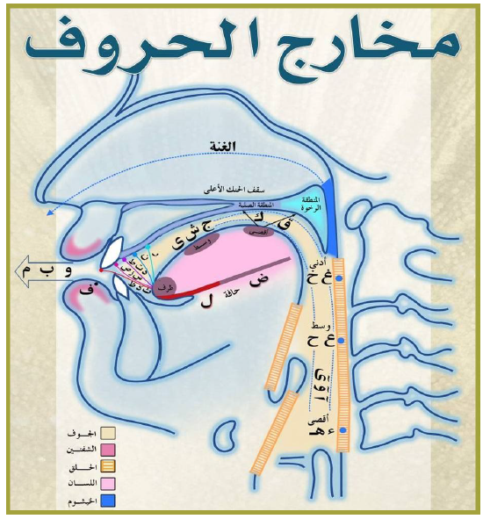

***Makharij*** meansthe place of emitting the letter during pronouncing.

The five main ***Makharij*** are:

1. ***Al-Jawf***
2. ***Al-Halq***
3. ***Al-Lisaan***
4. ***Ash-Shafataan***
5. ***Al-Khayshoom***

***1- Makhraj Al-Jawf***

***Definition:***

***It is the empty space in the mouth and throat.***

***Its letters:***

***1- Alif saakinah with a fathah before it.***

***2- Yaa’ saakinah with a kasrah before it.***

***3- Waaw saakinah with a dammah before it.***

It can be collected in one word: نُوحِيهَا

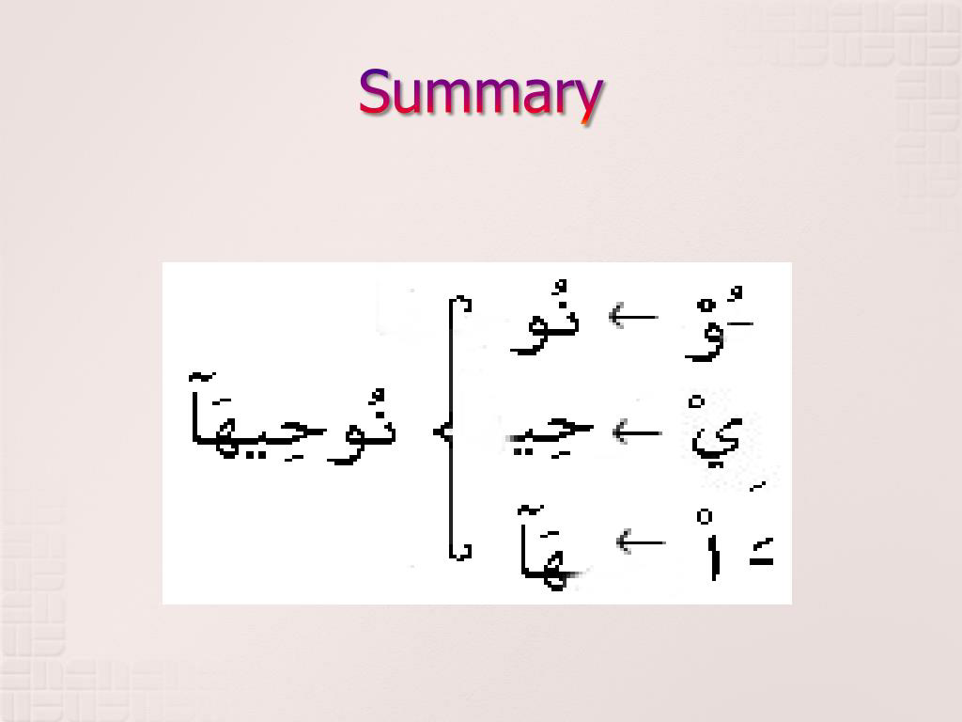

**2- *Makhraj Al-Halq***

***Definition***

***It means the throat.***

***Its letters:***

***It has three articulation points for six letters***, as follows:

1- The deepest part of the throat: **Hamzah-ء Haa’ هـ**

2- The middle of the throat:**Haa’ح -Ayn ع**

3- The closest part of the throat***: Khaa’خ******-Gyan غ***

**4- *Makhraj Al-Lisaan***

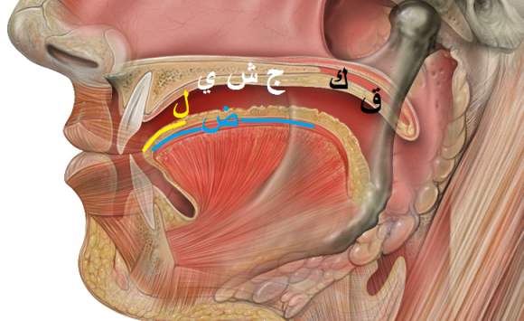

1. **Articulation points not from the tip of the tongue:**

-The deepest part of the tongue& roof of the mouth (soft palate)***:* Qaaf**ق

* Base of Tongue which is near Uvula touching the mouth roof

- The deepest part of the tongue& roof of the mouth (hard palate)***: Kaaf*** *ك*

* Portion of Tongue near its base touching the roof of mouth

- The middle of the tongue & hard palate: ***Jeem*** *-****جSheen******ش*** *-* ***yaa’******ي***

*Tongue touching the center of the mouth roof

**-** The side of the tongue & upper molars (left or right): **Daad** **ض**

**\***One side of the tongue touching the molar teeth

- Front edge of tongue & gums of upper front teeth**: Laam ل**

* Rounded tip of the tongue touching the base of the frontal 8 teeth

1. **Articulation points from the tip of the tongue:**

**-**Tip of tongue& gums of two front teeth**ن**

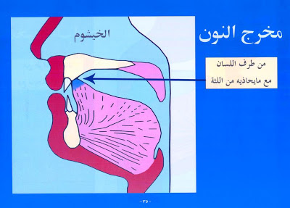

**-** Tip& top of the tongue with the gums of two front teeth **ر**

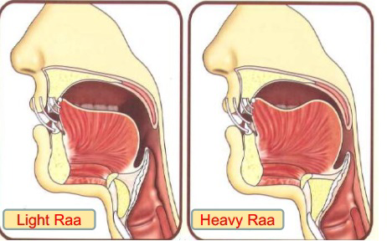

**-** Tip of tongue& gum line of two front teeth **ط د ت**

**-** Tip of tongue& plates of two lower front teeth **ص ز س**

**-** Tip of tongue & edges of two front teeth **ظ ذ ث**

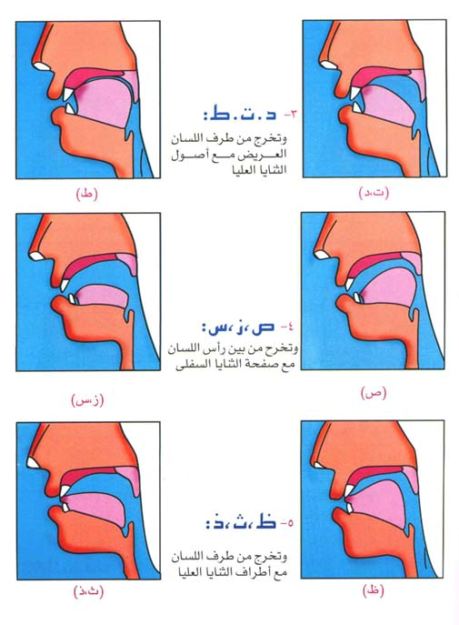

**Ash-Shafatain**

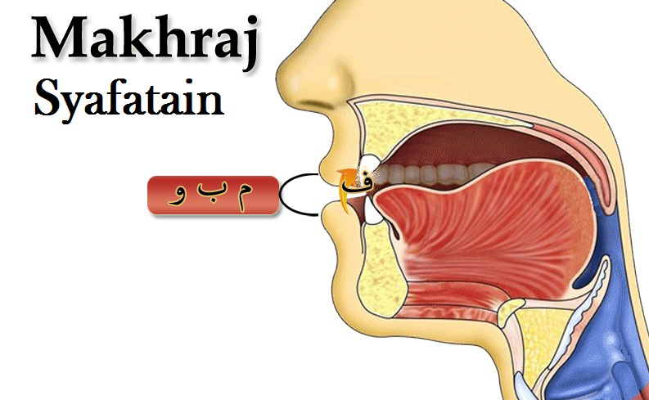

**Definition:**

**It means the two lips.**

**Its letters:**

* **Faa’ف:** Edges of two front teeth and inside of bottom lip
* **Waawو:** Circling of the two lips
* **Meem:** مClosing of the two lips
* **Baa’: ب** Closing of the two lips stronger than meemم

**Al-Khayshoum**

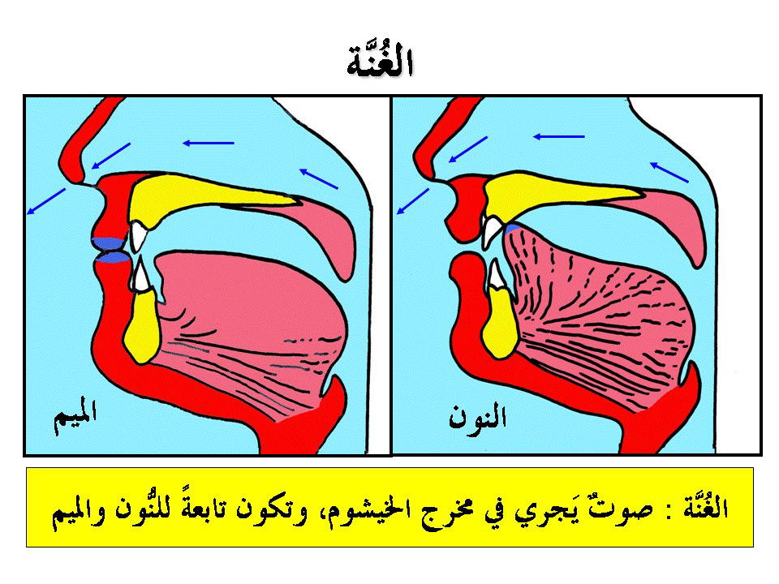

**Definition:**

**It means the nasal passage.**

**Its letters:**

This is where the ghunnah (the sound directed through the nose).

The ghunnah is a characteristic of noonن and meemم.